Holy-wood Academy’s
Sanjeevan Engineering & Technology Institute, Panhala
CIVIL Engineering Department

STAFF PROFILE INFORMATION
---------------------------------------------------------------------------------------
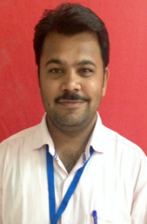
Name of Staff: - Mr. Birajdar Shatrughan Madhavrao
Designation: - Laboratory Technical Assistant
Qualification: - DCE
Area of Specialization:
Experience: ACADEMIC – 07 YEARS, INDUSTRIAL – 01 YEARS
email id:- shatrughna.birajdar@seti.edu.in
Contact Number: - 9764211545

